Dwarfing and Freeze Hardiness Potential of Trifoliate Orange Rootstocks¹
James J. Ferguson, Jose Chaparro, and Timothy M. Spann²
Commercial nurseries, growers, and homeowners who produce or grow citrus trees north of Gainesville should use a freeze hardy rootstock such as trifoliate orange (Poncirus trifoliata) or one of its hybrids. Trifoliate orange is in the same taxonomic family (Rutaceae) as other types of citrus like oranges (Citrus sinensis) and grapefruit (Citrus x paradisi) but it is in a different genus. It is not really an "orange" in the common sense of the word.
Other commercial citrus rootstocks also have trifoliate orange parentage. Carrizo citrange is a hybrid of Washington navel and trifoliate orange. Swingle citrumelo is a hybrid of Duncan grapefruit and trifoliate orange. The leaves of trifoliate orange and of other rootstocks with trifoliate orange parentage have "trifoliate" or compound leaves divided into three leaflets or sections (Fig. 1).
Trifoliate orange trees produce seedy, round, golf-ball-sized fruit (Fig. 2) that are unpalatable because of the presence of bitter oils. This species has the potential to survive low temperatures and, when used as a rootstock, can impart some freeze hardiness to scion trees grafted onto it. Trifoliate orange is also deciduous, shedding its leaves in the winter. Most citrus varieties propagated on trifoliate orange rootstock are also reduced in size, especially when Flying Dragon, a selection of trifoliate orange, is used. While Flying Dragon has shown some promise as a freeze hardy and dwarfing rootstock, questions often arise about its rootstock genetics, rootstock/scion interactions, and cultural practices that can affect tree size. Accordingly, the purpose of this fact sheet is to discuss these issues as they relate to trifoliate orange rootstocks, especially Flying Dragon.
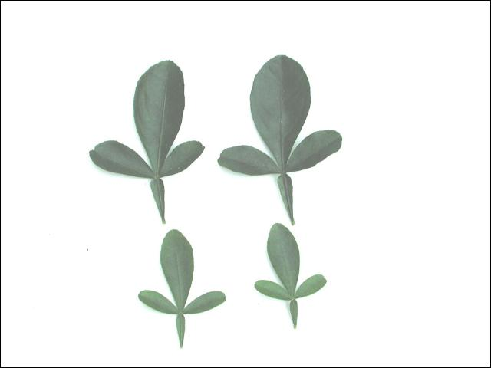Figure 1.
Compound leaves of trifoliate orange and related rootstocks are divided into three leaflets.
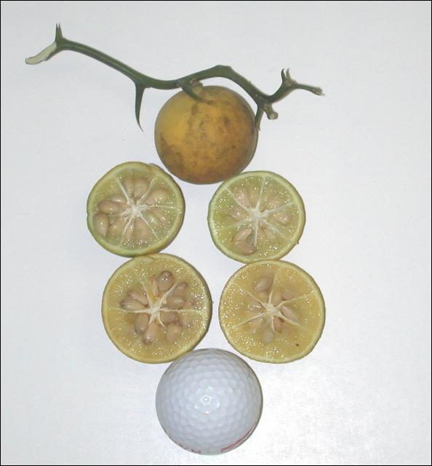
Figure 2.
Seedy fruit and stem of a trifoliate orange selection called Flying Dragon. Find the dragons in the twig.

How Does Dwarfing Occur?
For commercial growers and homeowners, a dwarf tree is simply one defined by convention as being about 5 to 6 feet tall at maturity. This particular tree height is somewhat arbitrary and is based mostly on comparison to a standard-sized tree, which is usually about 15 to 20 feet tall at maturity. In other words, a common grapefruit or sweet orange tree on "standard" or non-dwarfing commercial rootstocks will reach a 15 to 20-foot height at maturity, while a tree on Flying Dragon may grow to only "dwarf" size.
Commercial citrus growers have been interested in dwarfing rootstocks for citrus because small tree size allows a higher tree number or density per acre, fewer if any hedging and topping (pruning) costs, and easier fruit harvesting. A number of factors can influence tree size, but for most commercial citrus cultivars, research has shown that tree size can be greatly modified by selecting an appropriate rootstock. For example, trifoliate orange rootstock selections have been generally divided into two groups based on flower size. Trees on small-flowered trifoliate orange selections like Rubidoux are typically 15% to 20% smaller at maturity than trees on large-flowered selections like Pomeroy. In California, where dwarfing citrus rootstocks have been widely used, 8-to-12-year-old navel and Valencia oranges, Minneola tangelos, and Dancy tangerines on Rubidoux trifoliate orange rootstock at different sites ranged from 10 to 14 feet tall. Comparable trees on Pomeroy trifoliate rootstock were predicted to be 15%-20% taller, about 12 to 17 feet.
Using an interstock between the rootstock and the scion, done more successfully with apples than with citrus, can also reduce tree size. However, in some cases, rootstock effects can counteract interstock effects on tree size. For example, a Hamlin sweet orange scion on a Flying Dragon interstock on vigorous Volkamer lemon rootstock was 30% larger than Hamlin on a Flying Dragon interstock on less vigorous Carrizo citrange rootstock.
Environmental factors like soil type, mild drought, soil salinity or alkalinity, marginal growing sites, or climate can affect tree size. Trees on trifoliate orange rootstock are often smaller-sized when grown in deep, sandy soils even with irrigation. On better soils, these trees grow slowly but reach standard size. In Australia, deliberately infecting trees with the citrus exocortis viroid, a virus-like pathogen, has dwarfed trees but this procedure has not been widely adapted on a commercial scale because of potential risks and uncertainties related to using this pathogen. For example, in Florida, trees deliberately infected with citrus exocortis sustained greater freeze damage than comparable trees that were not infected.
Growth hormones like auxins and cytokinins have been used to reduce tree size and have decreased internode length (the distance between successive points of attachment of leaves on a stem) and increased lateral shoot development. Other cultural practices like growing otherwise standard rootstock/scion combinations in small pots will result in a dwarfed tree, but if such trees were transplanted into the home landscape or a commercial citrus grove, they could grow into standard size trees. To cite another example, bonsai, usually ranging from 2 inches to about 3 feet tall, are not genetically dwarfed plants but are standard size plants kept small by pruning branches and roots, repotting, and pinching off new growth. Small-leafed ornamentals like camellias are commonly used for bonsai but Flying Dragon rootstock, with its downcurved thorns and sinuous or winding growth habit, might also make an interesting bonsai specimen.

Characteristics of Trifoliate Orange Rootstock
Trifoliate orange is suitable for use in cool climates where maximum freeze hardiness can be developed. Freeze hardy rootstocks, like trifoliate orange, acquire freeze hardiness at 70°F day temperatures/50°F night temperatures whereas the less freeze hardy rootstocks do not acquire freeze hardiness until 50°F day/30°F night temperatures occur. During the fall and winter, cooler temperatures occur more frequently in northern than in central or southern Florida, but even in north Florida, unseasonably warm temperatures higher than 70°F day/50°F night cited above can reduce the freeze hardiness of trifoliate orange rootstocks. Trifoliate orange therefore may not be a consistently freeze hardy rootstock.
Given acclimating temperatures as unbudded seedlings, trifoliate orange rootstock is much more freeze hardy than most commercial citrus rootstock and scion cultivars. Trees on trifoliate orange rootstock also tend to be more freeze hardy than trees on other commercial rootstocks. Fully acclimated two-year old trifoliate orange seedlings survived 3°F temperatures in Georgia and Owari satsumas on trifoliate orange rootstock survived 14°F temperatures in Louisiana.
Interestingly, trees on Flying Dragon rootstock have not been shown to be more freeze hardy than trees on other trifoliate orange types. In one study examining the effects of rootstocks on freeze hardiness of navel oranges in California with minimum temperatures of 18°F and a long preceding period of freeze-hardening temperatures, trees on Flying Dragon were similar to trees on Pomeroy and Rubidoux trifoliate orange rootstocks. Note also that when severe freeze damage does occur to trees on trifoliate orange rootstock, they recover more slowly than trees on more freeze sensitive but more vigorous rootstocks like rough lemon.
Trifoliate orange is a satisfactory rootstock for most sweet orange cultivars, especially navels, but fruit size of grapefruit scions on trifoliate orange rootstocks may be relatively small. When trifoliate orange is used as a rootstock for mandarins and mandarin hybrids, bud union incompatibility has been reported. Trees budded on trifoliate orange produce excellent fruit with high soluble solids, good juice color and a smooth thin peel. Fruit also holds well on the tree. However, fruit, especially for the fresh market, can be small because of heavy fruit set.
When used as a rootstock, trifoliate orange can produce a standard-sized tree, about 15 feet tall, on clay and loamy soils and on shallow soils, but does not develop a deep or widely ranging root system and consequently is not drought tolerant. On deep, sandy Ridge soils, trees on trifoliate orange do not grow rapidly, making it a good candidate for close plantings with irrigation. It is poorly adapted to saline or calcareous conditions but is useful under wet conditions because of resistance to Phytophthora foot rot. Tree stunting and rootstock bark scaling associated with citrus exocortis and citrus blight, a decline of mature trees, are perhaps the most serious diseases affecting this rootstock. Some trifoliate orange selections are tolerant to citrus nematode but all selections are susceptible to burrowing nematode. Performance of trees on Flying Dragon rootstock may be similar to the above with tree size variability discussed in the following sections.

Polyembryony and Nucellar Seedlings
The genetics of trifoliate orange rootstocks are complex and may explain differences in the size of trees grafted onto these rootstocks, especially Flying Dragon. Citrus and related species are unique because of the frequent occurrence of polyembryony (one seed producing a number of embryos or seedlings) and nucellar embryony (seedlings genetically identical to the mother plant as opposed to zygotic seedlings which inherit genetic characteristics from both parent plants). Rootstocks that are strongly nucellar produce a high percentage of nucellar seedlings whereas weakly nucellar rootstocks can produce a significant percentage of both nucellar and zygotic seedlings. In one report, seed from Flying Dragon trees grown in four different locations produced between 0% and 75% zygotic seedlings. Researchers also found that the percentage of Flying Dragon nucellar and zygotic seedlings fluctuated greatly from year to year on the same tree.
When producing citrus nursery trees, nurserymen select rootstock seedlings for uniformity and discard any that are off-types that vary in characteristics like internode length, leaf size, shape and color, growth rate, foliage density, and branching. Such non-uniform or off-type seedlings probably developed from zygotic embryos (Figs. 3, 4, 5 and 6). If these off-types were used as rootstocks and grafted with a scion cultivar like Valencia orange, the resulting trees may not produce fruit of as uniform a quantity and quality as that same fruiting cultivar grafted onto comparable nucellar rootstock seedlings. Rootstock disease susceptibility could also vary. Although off-type rootstock seedlings should generally be avoided, they may have potentially interesting characteristics.
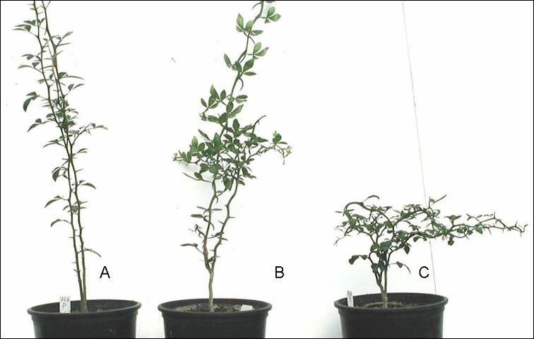Figure 3.
Flying Dragon seedlings from the same source. Note variability in stem height and relative straightness of stems and thorns.
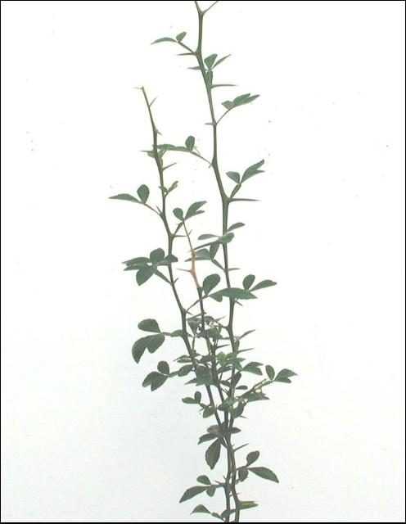Figure 4.
A closer image of plant A in Fig. 3.
The important point is that the occurrence of polyembryony and nucellar seedlings varies in trifoliate orange rootstocks. This variation can explain why Flying Dragon as a rootstock seedling and as a rootstock/scion combination can include both nucellar and zygotic seedlings and can produce both trees of standard size and trees of varying size, including dwarf trees. Environmental factors like soil conditions can also affect growth, tree size, and yield. Selected research on tree size, tree density per acre and yield of different scion cultivars on Flying Dragon rootstock is presented in Table 1.
Although the specific mechanism for dwarfing is not clearly understood, when used as both a rootstock and as an interstock, it has been suggested that Flying Dragon tissue may bind or inactivate translocation of a growth regulator produced by its roots. Further research may focus on identifying and transferring dwarfing factors to other rootstocks with more desirable traits.
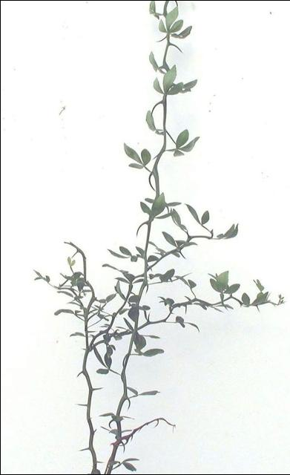
Figure 5.
A closer image of plant B in Fig. 3.
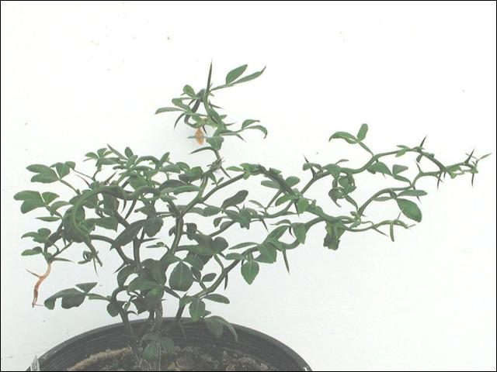Figure 6.
A closer image of plant C in Fig. 3. This appears to be a true-to-type genetic dwarf while the other plants may be off-types.

Table 1.
Selected research on growth and yield of scions on Flying Dragon (FD) rootstock
Experiment | Results | Country  (Publication date)
Mandarins, oranges and grapefruit on sour orange rootstock with a FD interstock | 11-year-old trees with an FD interstock were 1/3 smaller and had higher yield efficiency than trees without the interstock. | Italy (1989)
Minneola tangelo on Cleopatra mandarin rootstocks with four interstocks, including FD and two budding methods | FD and other interstocks had no effect on tree height as compared with the same scion on the same rootstocks. | Florida (1992)
Mandarins and grapefruit on sour orange, Rangpur lime, and other rootstocks with a FD interstock planted deeply, assumably to induce interstock rooting to control tree size after early vigorous growth with the sour orange rootstock | 6-year-old trees trees with a FD interstock were 30-50% smaller. Trees planted at a 3 x 16 ft. spacing had a 1.6 ft.³ tree volume and 67 lbs/tree yield. | Israel (1992)
Minneola tangelo on nine rootstocks, including FD | 3.5-year-old Minneola tangelo trees on FD rootstock were 30% shorter (4.7 feet) than Minneola tangelos on Cleopatra mandarin rootstock (6.8 ft). | Florida (1992)
8 citrus cultivars on FD | At 5 years old, trees could be planted at 333 - 583 trees/acre, 5X more than a conventional orchard at 1.8X greater costs and 5.2 X greater production. | New Caledonia (1999) (South Pacific off Australia)
Lemons on FD | 12-year-old trees had 1/3 the canopy volume of trees on sour orange rootstock with fruit yield of 441 lbs/tree. Trees were 11.5 ft. tall. | Argentina (1996)
Sweet oranges, mandarins, and Clementines on FD | Varying dwarfing capacity affected by scion and soil characteristics. Irregular canopy growth and poor production over extended periods. | Italy (1999)
Oranges, lemons, and Clementines on FD | High density plantings on FD at 6.5 x 6.5 ft spacings did not result in increased yields per unit area compared with conventional planting. FD did not restrict growth of vigorous lemon scions. | Italy (1992)
Sweet orange on FD | 9-year-old trees were 6 feet tall and @ 4.5 ft in width. | California (1982)
Pineapple sweet orange and Ruby grapefruit | 5-year old pineapple sweet orange and Ruby grapefruit trees (15 x 20) on Flying Dragon rootstock were 3.2 and 4.0 feet tall, respectively, compared with the same scions on Carrizo citrange which were 6.6 and 6.0 feet tall, respectively. | Florida (1980)
Valencia on FD | 4-year-old trees (averaging 4 feet tall and three feet wide) averaged 71 fruit per tree compared with trees of the same age on a vigorous rootstock, rough lemon (10 feet tall and 7 feet wide) averaging 541 fruit per tree. | California (1986)
Valencia on FD | 5-year-old trees (6 feet tall and 6 feet wide) | California (1979)
Few if any experiments in the same location with similar soil types and environmental conditions compare tree density/acre, tree size, yield, and fruit quality of the same scions on Flying Dragon rootstock.

Footnotes
1.
This document is HS982, one of a series of the Horticultural Sciences Department, Florida Cooperative Extension Service, Institute of Food and Agricultural Sciences, University of Florida. Original publication date October 2004. Revised April 2010. Visit the EDIS website at http://edis.ifas.ufl.edu.
2.
James J. Ferguson, professor emeritus, Jose Chaparro, assistant professor, and Timothy M. Spann, assistant professor, Horticultural Sciences Department, Cooperative Extension Service, Institute of Food and Agricultural Sciences, University of Florida, Gainesville, 32611.

The Institute of Food and Agricultural Sciences (IFAS) is an Equal Opportunity Institution authorized to provide research, educational information and other services only to individuals and institutions that function with non-discrimination with respect to race, creed, color, religion, age, disability, sex, sexual orientation, marital status, national origin, political opinions or affiliations. For more information on obtaining other UF/IFAS Extension publications, contact your county's UF/IFAS Extension office.
U.S. Department of Agriculture, UF/IFAS Extension Service, University of Florida, IFAS, Florida A & M University Cooperative Extension Program, and Boards of County Commissioners Cooperating. Nick T. Place, dean for UF/IFAS Extension.

